**SUBQUERIES, SAVEPOINT AND ROLLBACK**

* **SUBQUERIES FROM DIFFERENT TABLE:**

SELECT LAST_NAME, DEP_ID,E_ID

FROM EMPLOYEEE

WHERE DEP_ID=(SELECT DEP_ID FROM DEPARTMENT1 WHERE DEP_NAME='AIDS')

ORDER BY E_ID;

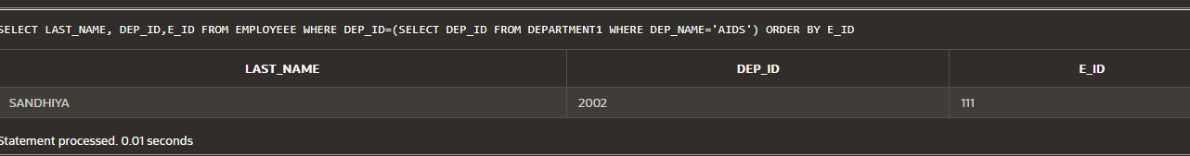

* **GROUP FUNCTION SUBQUERIES:**

SELECT FIRST_NAME, SALARY

FROM EMPLOYEES

WHERE SALARY< (SELECT AVG(SALARY) FROM EMPLOYEES);

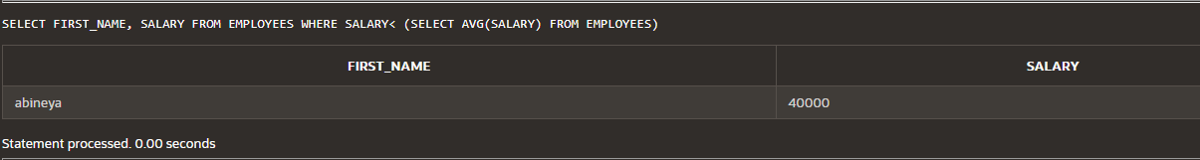

**ROLLUP:**

* **ROLLUP RESULT FORMULA:**

SELECT JOB_ID, EMPLOYEE_ID,SUM(SALARY)

FROM EMPLOYEES

WHERE EMPLOYEE_ID < 6

GROUP BY ROLLUP(JOB_ID,EMPLOYEE_ID);

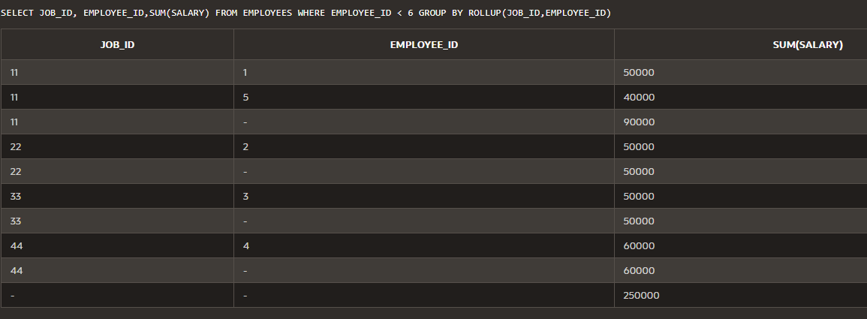

* **WITHOUT ROLLUP:**

SELECT JOB_ID, EMPLOYEE_ID,SUM(SALARY)

FROM EMPLOYEES

WHERE EMPLOYEE_ID < 6

GROUP BY (JOB_ID,EMPLOYEE_ID);

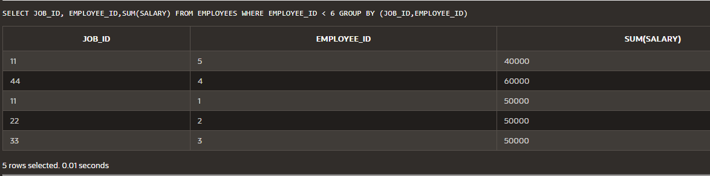

* **CUBE:**

SELECT JOB_ID, EMPLOYEE_ID,SUM(SALARY)

FROM EMPLOYEES

WHERE EMPLOYEE_ID < 6

GROUP BY CUBE (JOB_ID,EMPLOYEE_ID);

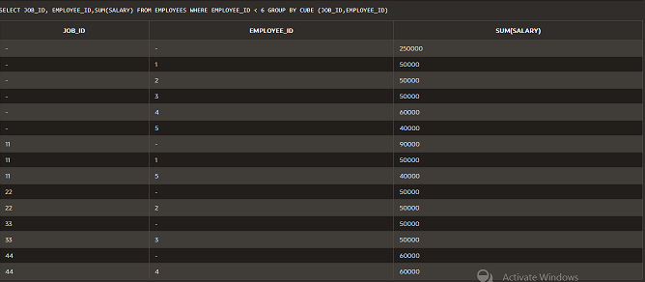

* **GROUPING SETS:**

SELECT JOB_ID, EMPLOYEE_ID,JOB_NAME,SUM(SALARY)

FROM EMPLOYEES

WHERE EMPLOYEE_ID < 6

GROUP BY GROUPING SETS ((JOB_ID,EMPLOYEE_ID),(JOB_ID,JOB_NAME),(EMPLOYEE_ID,JOB_NAME));

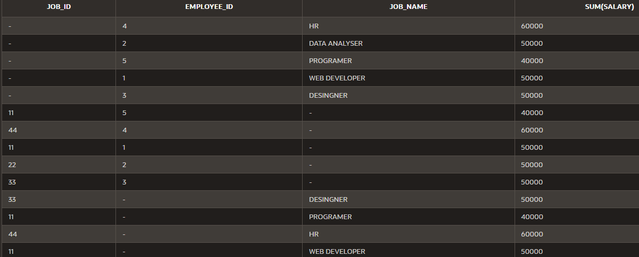

* **SET OPERATORS:**
* **UNION ALL**

SELECT DEP_ID

FROM EMPLOYEEE

UNION ALL

SELECT DEPT_ID

FROM SAVEETHA;

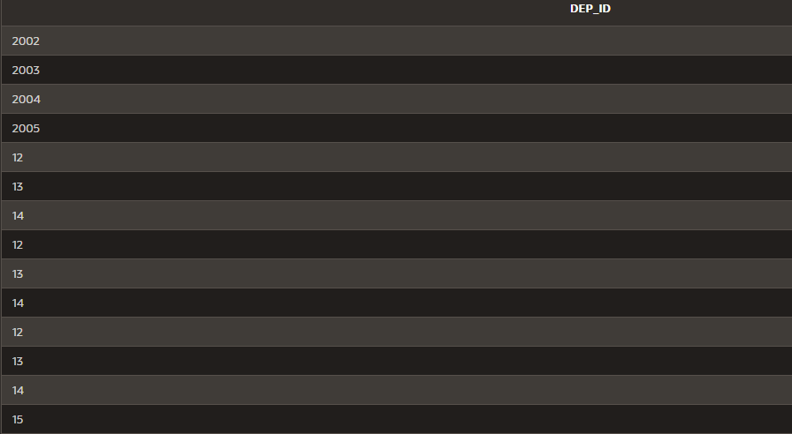

* **INTERSECT:**

SELECT DEP_ID

FROM EMPLOYEEE

INTERSECT

SELECT DEPT_ID

FROM SAVEETHA;

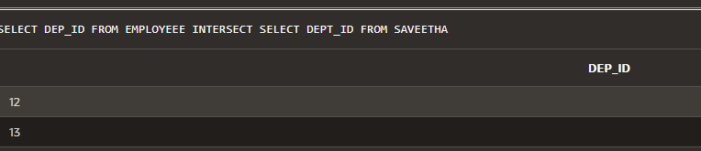

* **MINUS:**

SELECT DEP_ID

FROM EMPLOYEEE

MINUS

SELECT DEPT_ID

FROM SAVEETHA;

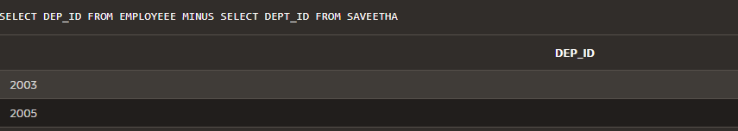

* **SET OPERATION ORDER BY:**

SELECT DEP_ID, LAST_NAME

FROM EMPLOYEEE

UNION

SELECT DEPT_ID,DEPT

FROM SAVEETHA

ORDER BY LAST_NAME;

